**Create a School Database**

GitHub Link : <https://github.com/pravallikaadineni/mainprojects.git>

Step 1: create a new database school

**Query**: create database school

use school

step 2: creating student, class and subject tables in the school database

create database schoolDB

use schoolDB

create table class

(

classno int primary key,

)

create table student

(

studid int primary key,

studname varchar(20),

)

create table subject

(

subid int primary key,

subname varchar(20),

)

alter table subject

add classno int constraint fk_prfk foreign key references class(classno)

alter table class

add studid int constraint fk_stfk foreign key references student(studid)

alter table class

add subid int constraint fk_sufk foreign key references subject(subid)

alter table student

add subid int constraint fk_sutdfk foreign key references subject(subid)

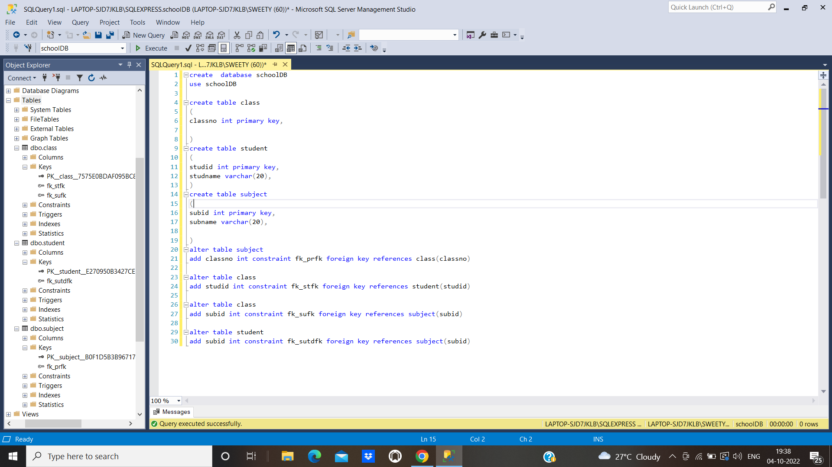

Step 3: Push the code to your GitHub repository

● Open your command prompt and navigate to the folder where you have created your files.

**cd <folder path>**

● Initialize your repository using the following command:

**git init**

● Add all the files to your Git repository using the following command:

**git add .**

● Commit the changes using the following command:

**git commit . -m “upload”**

● Push the files to the folder you initially created using the following command:

**git push -u origin main**